- FEED FORWARD NEURAL NETWORK (FFNN)
AIM
To implement a simple Feed Forward Neural Network (FFNN) in Python using manually entered inputs, weights, and bias.
OBJECTIVE
- To understand the working of a Feed Forward Neural Network.
- To calculate the weighted sum of inputs.
- To apply an activation function.
- To produce the final output using manual input.
ALGORITHM
- Start the program.
- Enter the input values manually.
- Enter the corresponding weights and bias.
- Calculate the weighted sum:
z = x1*w1 + x2*w2 + b
- Apply the step activation function.
- If z >= 0, output 1; otherwise output 0.
- Display the output.
- Stop.
FLOWCHART:
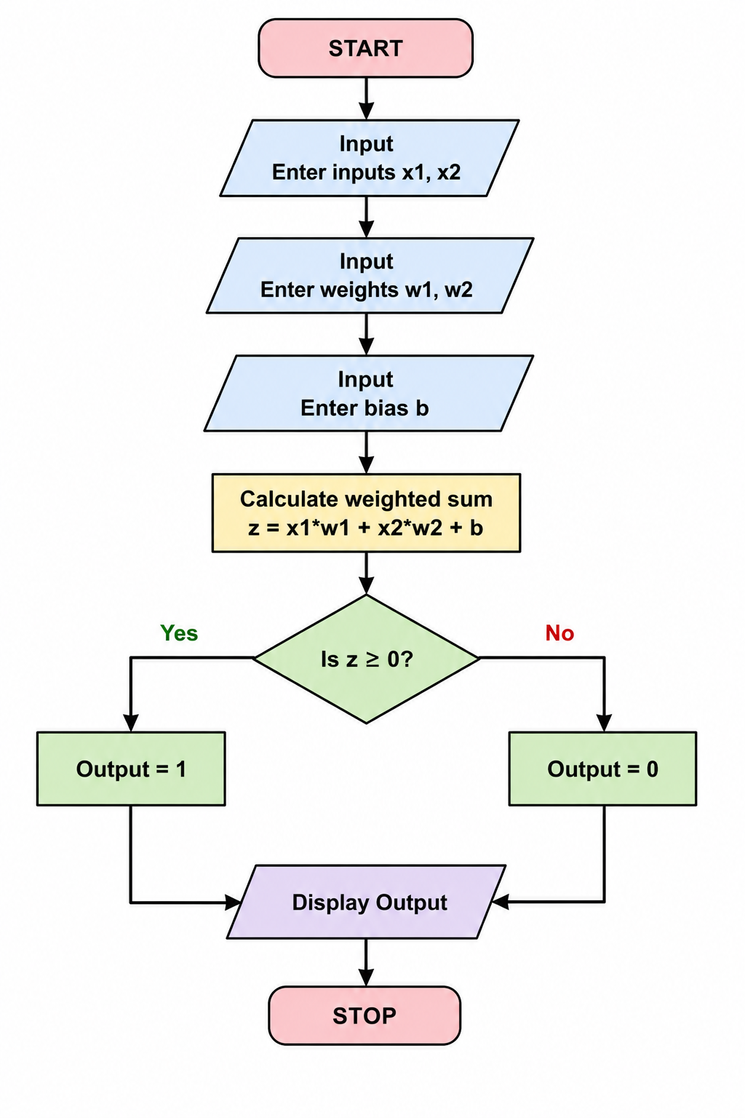
PYTHON CODE:
x1 = float(input("Enter input 1: "))
x2 = float(input("Enter input 2: "))
w1 = float(input("Enter weight 1: "))
w2 = float(input("Enter weight 2: "))
b = float(input("Enter bias: "))
z = x1*w1 + x2*w2 + b
if z >= 0:
output = 1
else:
output = 0
print("Output:", output)
OUTPUT:
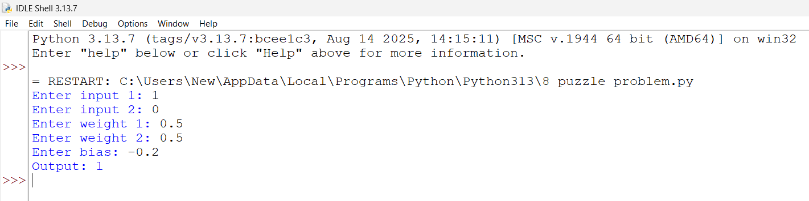
RESULT:
Thus, the Feed Forward Neural Network was successfully implemented in Python. The program accepts inputs, weights, and bias manually, calculates the weighted sum, applies an activation function, and produces the final output.

